How to Make a Public Website

September 11, 2020 by Kalvis

**Description:** This step-by-step walkthrough shows how to publish a website for your own projects or to make an unofficial website for your project team.

In “First Year Seminar” we suggest that every team publish their reference information (bookmarks, other useful links, indications where to get “weakly protected” project prototype, etc.) on their website.

By September 15, 2020 your team needs to publish **at least 10 bookmarks** on their website (and include the link of the website in your Team Working Agreement). All the bookmarks should be relevant to your project goals. If you wish, you can create public websites for every team member, but every team should have one **Main Team Website**. It will be inspected and evaluated.

This guide shows an easy way to create public websites. You are free to use any other approach. BITL students (and also BBA students who like computer programming) might find this way appealing, since it relies on GitHub – the most popular version control software that is used in many other classes as well.

# Create an account on GitHub

**Step 1:** Visit <https://github.com/> on any browser (You can complete this Walk-through even on a mobile device.) Click on button Sign-Up. Or log in, if you have a GitHub account already.

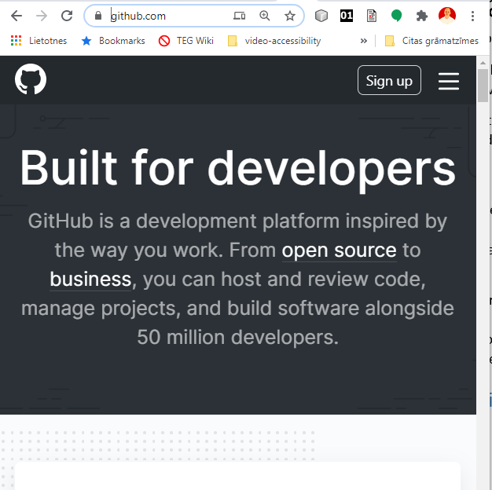

**Step 2:** Fill in the details about your account (username, email, password), and click on Verify.

GitHub application might send you a verification email to make sure that the email account belongs to you. In this case you would need to click on a link you received in your mailbox, and log into GitHub again.

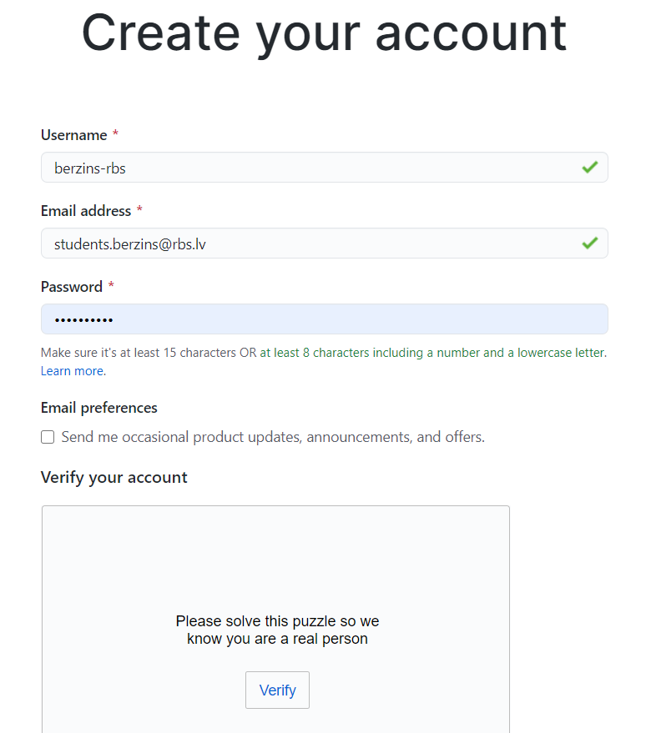

**Step 3:** Go to a Dashboard. Once you are logged in GitHub, click on the Cat-Logo. Pick Dashboard from the drop-down menu.

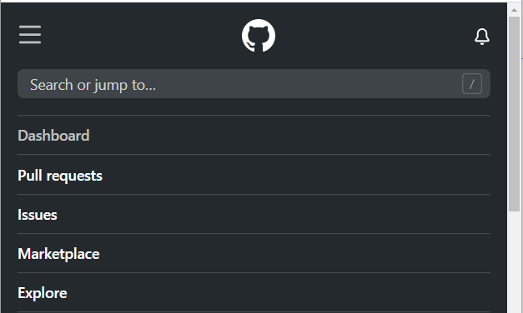

**Step 4:** Click on **Start a Project** button. And select repository name. It should consist of lower-case Latin letters (separated by dashes, if you want).   
(In our example it is “**public-website**”). Click on **Create a Repository** button below.

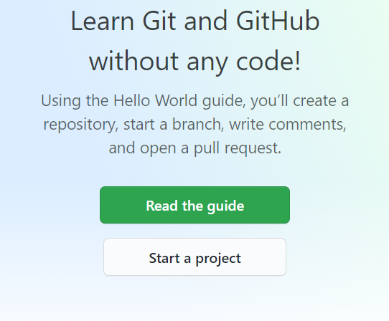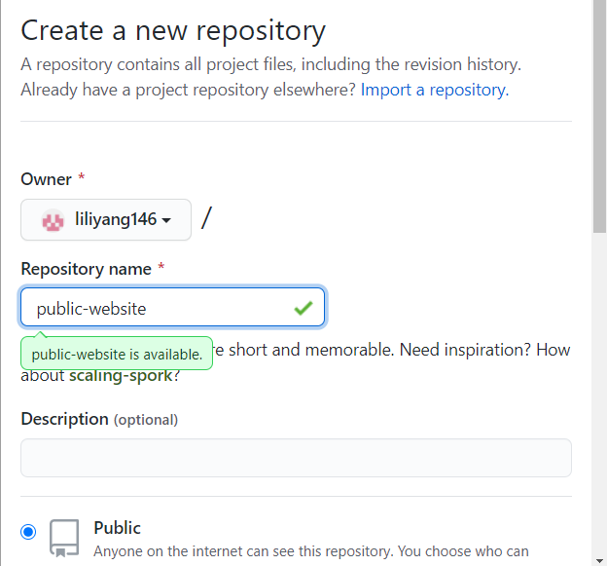

**Step 5:** Click on the link “**Creating a new file**”. Name your file **index.html**.

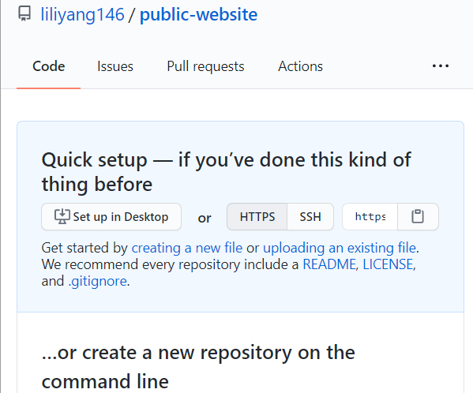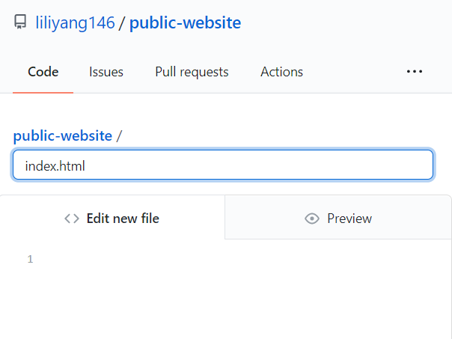

**Step 6:** Create a simple HTML code there.

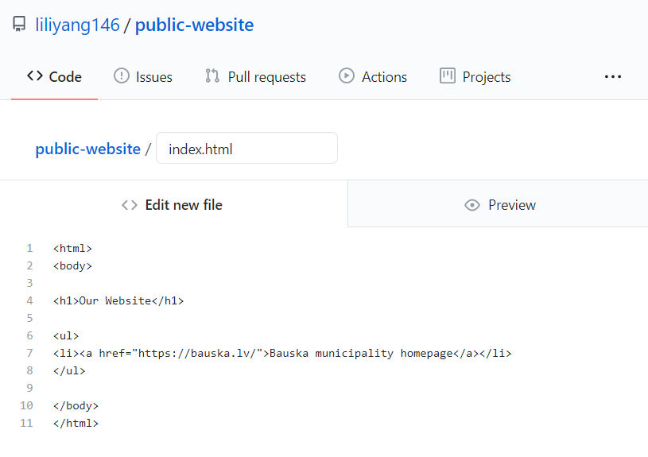

**Step 7:** Click on “Commit a new file” button at the bottom.

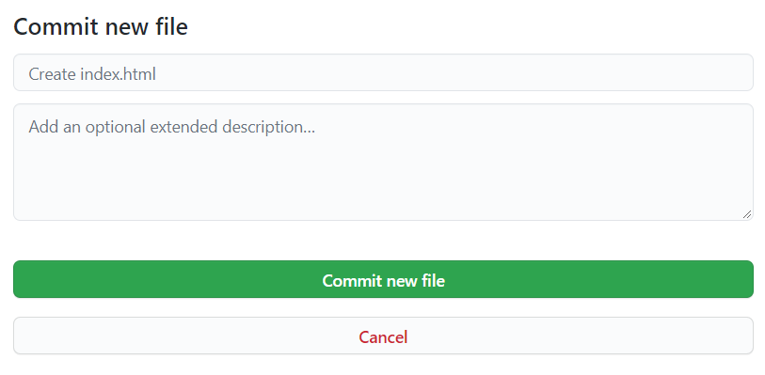

**Step 8:** Click on “Settings” (top right menu item):  
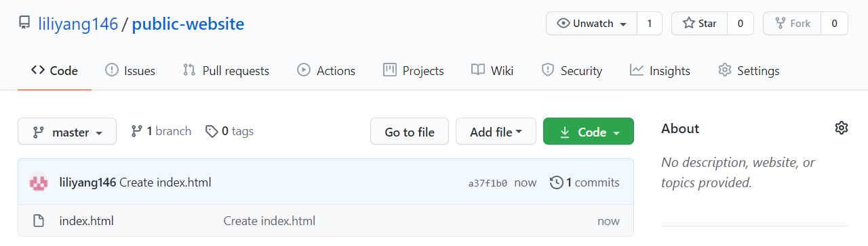

**Step 9:** Publish it on the Web. Scroll down to “GitHub Pages”, pick “master” branch. Click **Save**.

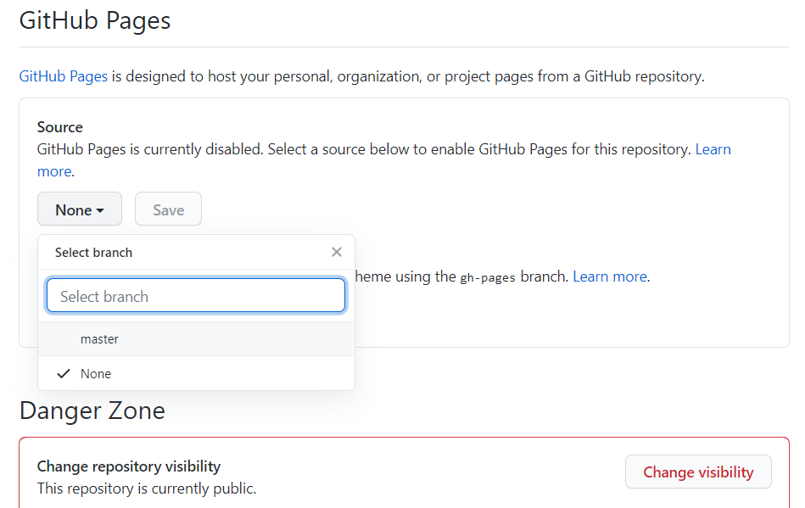

**Step 10:** Check the URL and visit your webpage.

